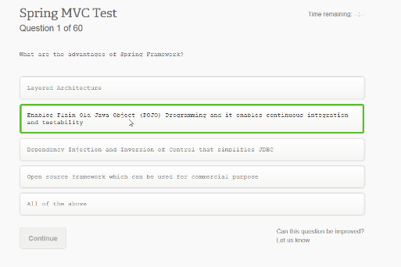

What are the advantages of Spring Framework?

Layered Architecture

Enables Plain Old Java Object (POJO) Programming and it enables continuous integration and testability

Dependency Injection and Inversion of Control that simplities JDBC

Open source framework wich can be used for commercial purpose

**All of the above**

Câu trả lời hiển nhiên là “All of the above”

Dẫn chứng:

**48) What are the advantages of spring framework?**

Following are the advantages of spring framework:

* Layered Architecture
* Enables Plain Old Java Object (POJO) Programming and it enables continuous integration and testability
* Dependency Injection and Inversion of Control that simplifies JDBC
* Open source framework which can be used for commercial purpose

<https://www.guru99.com/spring-mvc-framework-interview-questions.html>

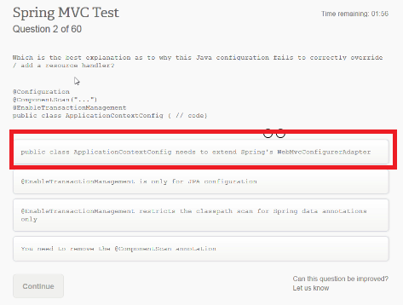

**Which is the best explanation as to why this java configuration fails to correctly override / add a resource handler?**  
@Configuration  
@ComponentScan(“…..”)  
@EnableTransactionManagment  
public class ApplicationContextConfig { // code}  
Answer

* **public class ApplicationContextConfig nedds to extend Spring’s** **webconfigurerAdapter**
* @EnableTransactionManagement is the only for JPA configuration
* @EnableTransactionManagement restricts the classpath scan for Spring data annotation only
* You need to remove the @ComponentScan annotation

Câu trả lời là phải extend **webconfigurerAdapter**

Dẫn chứng: <https://stackoverflow.com/questions/39674533/how-to-add-resourcehandler-in-spring-mvc-4-java-configuration>

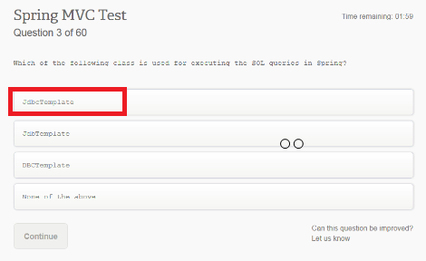

JdbcTemplate

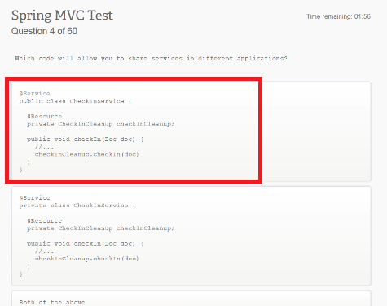

Các câu hỏi từ Spring Mock Test

Q 1 - What is spring?

**A - Spring is an open source development framework for enterprise Java.**

B - Spring is a proprietary framework.

C - Spring is a development framework for .Net applications.

D - Spring is a development framework for PHP based applications

Q 2 - Which of the following is correct assertion about spring?

A - Spring enables developers to develop enterprise-class applications using POJOs.

B - Spring is organized in a modular fashion.

C - Testing an application written with spring is simple because environment-dependent code is

moved into this framework.

**D - All of above.**

Q 3 - What is Dependency Injection?

**A - It is a design pattern which implements Inversion of Control for software applications.**

B - It is one of the spring module.

C - It is a technique to get dependencies of any project.

D - It is used to promote tight coupling in code.

Q 4 - Which of the following is correct about dependency injection?

**A - It helps in decoupling application objects from each other.**

B - It helps in deciding the dependencies of objects.

C - It stores objects states in database.

D - It stores object states in file system.

Q 5 - What AOP stands for?

**A - Aspect Oriented Programming**

B - Any Object Programming

C - Asset Oriented Programming

D - Asset Oriented Protocol

Q 6 - What is true about cross-cutting concerns?

A - **The functions that span multiple points of an application are called cross cutting concerns.**

B - Cross-cutting concerns are conceptually separate from the application's business logic.

C - Logging is one of the examples of cross cutting concerns.

D - All of the above.

Q 7 - Which are the modules of core container?

**A - Beans, Core, Context, SpEL**

B - Core, Context, ORM, Web

C - Core, Context, Aspects, Test

D - Bean, Core, Context, Test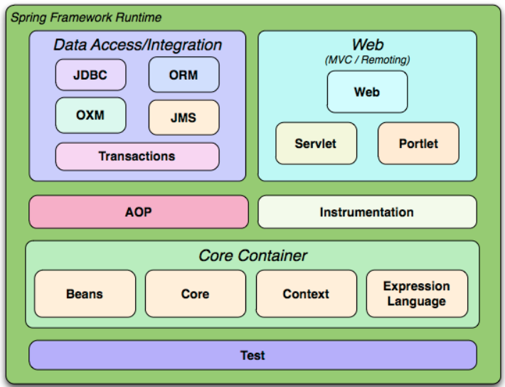

Q 8 - Which are the modules of Data Access/ integration layer?

**A - JDBC, ORM, OXM, JMS, Transactions**

B - JDBC, ORM, OXM, JMS

C - JDBC, ORM, Web, Beans

D - JDBC, ORM, OXM, JMS

Q 9 - Which are the modules of Web layer?

**A - WebSocket, Servlet, Web, Portlet**

B - WebSocket, Servlet, Web-MVC, Web

C - HTML, JSP, WEB, Portlet

D - HTML, Servlet, WEB, Portlet

Q 10 - Which of the statement is not correct?

A - Core and beans modules provide the fundamental parts of the framework, including

Dependency Injection feature.

B - The SpEL module provides a powerful Expression Language for querying and manipulating an

object graph at runtime.

C - Aspects module provides integration with AspectJ.

**D - None of the above.**

Q 11 - Which of the statement is correct?

A - The JDBC module provides a JDBC-abstraction layer that removes the need to do tedious JDBC

related coding.

B - The ORM module provides integration layers for popular object-relational mapping APIs,

including JPA, JDO, Hibernate, and iBatis.

C - The Java Messaging Service JMS module contains features for producing and consuming

messages.

**D - All of the above.**

Q 12 - Which of the statement is correct?

A - The AOP module provides aspect-oriented programming implementation allowing you to

define method-interceptors and pointcuts to cleanly decouple code that implements functionality

that should be separated.

B - The Aspects module provides integration with AspectJ - Which is again a powerful and mature

aspect oriented programming AOP framework.

C - The Instrumentation module provides class instrumentation support and class loader

implementations to be used in certain application servers.

**D - All of the above.**

Q 13 - What types of Dependency injection does spring supports?

**A - Constructor based, Setter based**

B - Constructor based, Setter based, Getter Based

C - Setter based, Getter based, Properties based

D - Constructor based, Setter based, Properties based

Q 14 - Which are the IoC containers in Spring?

**A - BeanFactory, ApplicationContext**

B - BeanFactory, ApplicationContext, IocContextFactory

C - BeanFactory, BeanContext, IocContextFactory

D - BeanFactory, ApplicationContext, BeanContext

Q 15 - Which is the correct implementation class of BeanFactory?

**A - XmlBeanFactory**

B - ClassPathBeanFactory

C - FileSystemBeanFactory

D - AdvancedBeanFactory

Q 16 - Which are the correct implementation classes of ApplicationContext?

**A - FileSystemXmlApplicationContext, ClassPathXmlApplicationContext,**

**WebXmlApplicationContext**

B - FileSystemApplicationContext, ClassPathApplicationContext, WebApplicationContext

C - AdvancedApplicationContext, FileApplicationContext

D - FileSystemApplicationContext, ClassPathApplicationContext

Q 17 - Which of the following stands true for spring beans?

A - Spring beans are managed by the Spring IoC container.

B - Spring beans are instantiated, assembled, and otherwise managed by a Spring IoC container.

C - Spring beans are simple POJOs.

**D - All of the above.**

Q 18 - Which is the way to provide configuration metadata to spring?

A - XML Based configuration file.

B - Annotation based configuration.

C - Java based configuration.

**D - All of the above.**

Q 19 - What is bean scope?

**A - Bean scope forces Spring to produce a new bean instance as per the scope defined.**

B - Bean scope defines the accessibility of bean in a java class.

C - Bean scope defines the accessibility of bean in a java package.

D - Bean scope defines the accessibility of bean in a web application

For more information:

**1. singleton(default*)**

Scopes a single bean definition to a single object instance per Spring IoC container.

**2. prototype**

Scopes a single bean definition to any number of object instances.

**3. request**

Scopes a single bean definition to the lifecycle of a single HTTP request; that is each and every HTTP request will have its own instance of a bean created off the back of a single bean definition. Only valid in the context of a web-aware Spring ApplicationContext.

**4. session**

Scopes a single bean definition to the lifecycle of a HTTP Session. Only valid in the context of a web-aware Spring ApplicationContext.

**5. global session**

Scopes a single bean definition to the lifecycle of a global HTTP Session. Typically only valid when used in a portlet context. Only valid in the context of a web-aware Spring ApplicationContext.

Ví dụ về sự khác nhau giữa singleton và prototype

_ Singleton là mặc định. Mỗi lần start Spring lên, IoC container sẽ tạo 1 instance cho cái bean đó và lưu nó trong cache. Bây giờ xài thì chỉ việc lấy ra xài thôi

_ Prototype khác singleton ở chỗ mỗi lần xài, thì nó k lôi trong cache ra, mà nó lại tạo ra 1 instance mới.

Nói thêm về prototype pattern

Prototype allows us to hide the complexity of making new instances from the client. The concept is to copy an existing object rather than creating a new instance from scratch, something that may include costly operations. The existing object acts as a prototype and contains the state of the object. The newly copied object may change same properties only if required. This approach saves costly resources and time, especially when the object creation is a heavy process.

Nghĩa là nó sẽ clone 1 instace từ cache ra, do đó mình có thể chỉnh sửa trên instance mới này.

**Q 20 - What is singleton scope?**

**A - This scopes the bean definition to a single instance per Spring IoC container.**

B - This scopes the bean definition to a single instance per HTTP Request.

C - This scopes the bean definition to a single instance per HTTP Session.

D - This scopes the bean definition to a single instance per HTTP Application/ Global session.

**Q 21 - What is prototype scope?**

**A - This scopes a single bean definition to have any number of object instances.**

B - This scopes the bean definition to a single instance per HTTP Request.

C - This scopes the bean definition to a single instance per HTTP Session.

D - This scopes the bean definition to a single instance per HTTP Application/ Global session.

**Q 22 - What is request scope?**

**A - This scopes a bean definition to an HTTP request.**

B - This scopes the bean definition to Spring IoC container.

C - This scopes the bean definition to HTTP Session.

D - This scopes the bean definition HTTP Application/ Global session.

**Q 23 - What is session scope?**

**A - This scopes a bean definition to an HTTP session.**

B - This scopes the bean definition to Spring IoC container.

C - This scopes the bean definition to HTTP request.

D - This scopes the bean definition to HTTP Application/ Global session.

**Q 24 - What is global-session scope?**

**A - This scopes a bean definition to an HTTP Application/ Global session.**

B - This scopes the bean definition to Spring IoC container.

C - This scopes the bean definition to HTTP request.

D - This scopes the bean definition to HTTP Session.

**Q 25 - What is default scope of bean in Spring framework?**

**A - singleton**

B - prototype

C - request

D – session

**Q 26 - How can you inject Java Collection in Spring?**

**A - Using list, set, map or props tag.**

B - Using lit, set, map or collection tag.

C - Using list, set, props or collection tag.

D - Using list, collection, map or props tag.

It’s very interesting here:

<https://www.baeldung.com/spring-injecting-collections>

**Q 27 - What is true about <list> collection configuration elements?**

**A - This helps in wiring a list of values, allowing duplicates.**

B - This helps in wiring a list of values but without any duplicates.

C - This can be used to inject a collection of name-value pairs where name and value can be of

any type.

D - This can be used to inject a collection of name-value pairs where the name and value are

both Strings.

**Q 28 - What is true about <set> collection configuration elements?**

A - This helps in wiring a list of values, allowing duplicates.

**B - This helps in wiring a list of values but without any duplicates.**

C - This can be used to inject a collection of name-value pairs where name and value can be of

any type.

D - This can be used to inject a collection of name-value pairs where the name and value are

both Strings.

**Q 29 - What is true about <map> collection configuration elements?**

A - This helps in wiring a list of values, allowing duplicates.

B - This helps in wiring a list of values but without any duplicates.

**C - This can be used to inject a collection of name-value pairs where name and value can be of**

**any type.**

D - This tag is not supported.

**Q 30 - What is true about <props> collection configuration elements?**

A - This helps in wiring a list of values, allowing duplicates.

B - This helps in wiring a list of values but without any duplicates.

C - This can be used to inject a collection of name-value pairs where name and value can be of

any type.

**D - This can be used to inject a collection of name-value pairs where the name and value are**

**both Strings.**

**Q 31 - What is bean autowiring?**

**A - Autowiring lets Spring resolve collaborators *otherbeans* for your bean by inspecting the contents**

**of the BeanFactory without using <constructor-arg> and <property> elements.**

B - Autowiring injects values in spring beans.

C - Autowiring injects one bean into another.

D - Autowiring helps in wiring a list of values, allowing duplicates.

**Q 32 - Which are the different modes of autowiring?**

**A - no, byName, byType, constructor, autodetect**

B - no, byName, byType, constructor, autocorrect

C - byName, byContent, constructor, autodetect

D - byName, byContent, setter, autodetect

**Q 33 - What is no mode of autowiring?**

**A - Default setting which means no autowiring and you should use explicit bean reference for**

**wiring.**

B - Autowiring by property name.

C - Spring first tries to wire using autowire by constructor, if it does not work, Spring tries to

autowire by byType.

D - Similar to byType, but type applies to constructor arguments.

**Q 34 - What is byName mode of autowiring?**

A - Default setting which means no autowiring and you should use explicit bean reference for

wiring.

**B - Autowiring by property name. Spring tries to match and wire its properties with the beans**

**defined by the same names in the configuration file.**

C - Spring first tries to wire using autowire by constructor, if it does not work, Spring tries to

autowire by byType.

D - Similar to byType, but type applies to constructor arguments.

**Q 35 - What is byType mode of autowiring?**

A - Default setting which meas no autowiring and you should use explicit bean reference for

wiring.

B - Autowiring by property name. Spring tries to match and wire its properties with the beans

defined by the same names in the configuration file.

C - Spring first tries to wire using autowire by constructor, if it does not work, Spring tries to

autowire by byType.

**D - Autowiring by property type. Spring tries to match and wire a property if its type matches with**

**exactly one of the beans name in configuration file.**

**Q 36 - What is constructor mode of autowiring?**

A - Autowiring by property name. Spring tries to match and wire its properties with the beans

defined by the same names in the configuration file.

B - Spring first tries to wire using autowire by constructor, if it does not work, Spring tries to

autowire by byType.

C - Autowiring by property type. Spring tries to match and wire a property if its type matches with

exactly one of the beans name in configuration file.

**D - Similar to byType, but type applies to constructor arguments. If there is not exactly one bean**

**of the constructor argument type in the container, a fatal error is raised.**

**Q 37 - What is autodetect mode of autowiring?**

A - Similar to byType, but type applies to constructor arguments. If there is not exactly one bean

of the constructor argument type in the container, a fatal error is raised.

B - Autowiring by property name. Spring tries to match and wire its properties with the beans

defined by the same names in the configuration file.

**C - Spring first tries to wire using autowire by constructor, if it does not work, Spring tries to**

**autowire by byType.**

D - Autowiring by property type. Spring tries to match and wire a property if its type matches with

exactly one of the beans name in configuration file.

**Q 38**

Can you inject null and empty string values in Spring?

**A - Yes**

B – No

**Q 39 - How do you turn on annotation wiring?**

A - Add <annotation-context:config /> to bean configuration.

B - Add <annotation-config /> to bean configuration.

C - Add <annotation-context-config /> to bean configuration.

**D - Add <context:annotation-config/> to bean configuration.**

**Q 40 - What does @Required annotation mean?**

A - This annotation indicates that bean property must be populated by the user.

B - This annotation indicates that bean property is required while saving the bean data to

database.

**C - This annotation simply indicates that the affected bean property must be populated at**

**configuration time, through an explicit property value in a bean definition or through autowiring.**

D - This annotation indicates that bean property is required while serializing the bean.

**Q 41 - What is true about @Autowired annotation?**

A - The @Autowired annotation can be used to autowire bean on the setter method.

**B - This annotation provides more fine-grained control over where and how autowiring should be**

**accomplished.**

C - The @Autowired annotation can be used to autowire bean on the methods with arbitrary

names and/or multiple arguments.

D - All of above.

**Q 42 - What is ContextRefreshedEvent event?**

A - This event is published when the Servlet Context is either initialized or refreshed.

B - This event is published when the HTTP Request is received.

C - This event is published when the HTTP Response is returned.

**D - This event is published when the ApplicationContext is either initialized or refreshed.**

**Q 43 - What is ContextStartedEvent event?**

A - This event is published when the Servlet Context is either initialized or refreshed.

B - This event is published when the HTTP Request is received.

**C - This event is published when the ApplicationContext is started using the start method on the**

**ConfigurableApplicationContext interface.**

D - This event is published when the HTTP Response is returned.

**Q 44 - What is ContextStoppedEvent event?**

A - This event is published when the Servlet Context is either initialized or refreshed.

**B - This event is published when the ApplicationContext is stopped using the stop method on the**

**ConfigurableApplicationContext interface.**

C - This event is published when the HTTP Request is received.

D - This event is published when the HTTP Response is returned.

**Q 45 - What is ContextClosedEvent event?**

A - This event is published when the Servlet Context is either initialized or refreshed.

B - This event is published when the HTTP Request is received.

C - This event is published when the HTTP Response is returned.

**D - This event is published when the ApplicationContext is closed using the close method on the**

**ConfigurableApplicationContext interface.**

**Q 46 - What is RequestHandledEvent:event?**

A - This event is published when the Servlet Context is either initialized or refreshed.

B - This event is published when the HTTP Request is received.

**C - This event is published when the HTTP session is initialized or refreshed.**

D - This event is published when the HTTP Request is serviced.

**Q 47 - What is aspect?**

A - Aspect is a way to do the dependency injection.

**B - A module which has a set of APIs providing cross-cutting requirements.**

C - Aspect is used to log information of application.

D - Aspect represents properties of spring based application.

**Q 48 - What is Join point?**

A - This represents a point in your application which joins two objects.

B - This represents a point in your object where you join values.

C - This represents a point in your object where you join injected values.

**D - This represents a point in your application where you can plug-in AOP aspect.**

**Q 49 - What is Advice?**

A - This is the way to instruct object to behave in certain manner.

B - This is used to inject values in objects.

**C - This is the actual action to be taken either before or after the method execution.**

D - This is not invoked during program execution by Spring AOP framework.

**Q 50 - What is Pointcut?**

A - This represents a point in your application where you can plug-in AOP aspect.

**B - This is a set of one or more joinpoints where an advice should be executed.**

C - This is used to inject values in objects.

D - This is invoked during program execution by Spring AOP framework.

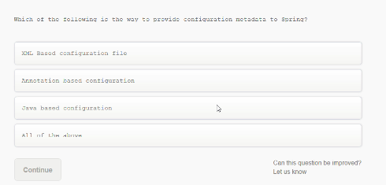

Which of the following is the way to provide configuration metadata to Spring?

Xml Based configuration file

Annotation based configuration

Java based configuration

**All of the above**

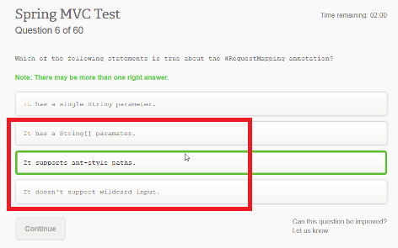

Which of the following statements is true about the @RequestMapping annotation

It has a single String parameter

**It has a String[] parameter**

**It supports ant-style paths**

It doesn’t support wildcard input

<https://docs.spring.io/spring-framework/docs/current/javadoc-api/org/springframework/web/bind/annotation/RequestMapping.html>

about ant-style:

<https://stackoverflow.com/questions/2952196/learning-ant-path-style>

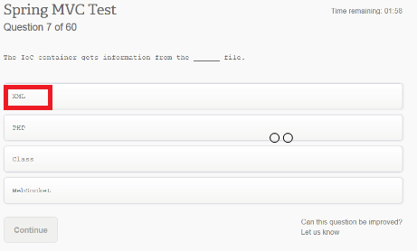

The IoC container gets information from the ___ file.

**XML**

PHP

Class

Web…?

The container gets its instructions on what objects to instantiate, configure, and assemble by reading the configuration metadata provided. The configuration metadata can be represented either by XML, Java annotations, or Java code. The following diagram represents a high-level view of how Spring works. The Spring IoC container makes use of Java POJO classes and configuration metadata to produce a fully configured and executable system or application.

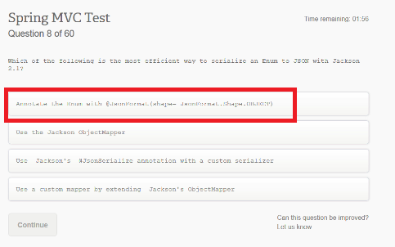

Which of the following is the most efficient way to serialize an Enum to Json with Jackson 2.1

**Annotation the enum with @JsonFormat….**

[**https://www.baeldung.com/jackson-serialize-enums**](https://www.baeldung.com/jackson-serialize-enums)

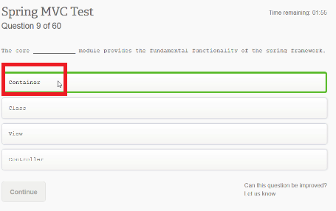

The core ____ module provides the fundamental functionality of the spring framework.

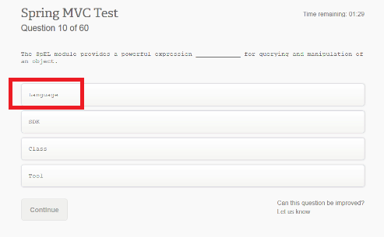

The SpEL module provides a powerful expression ____ fro querying and manipulation or an object

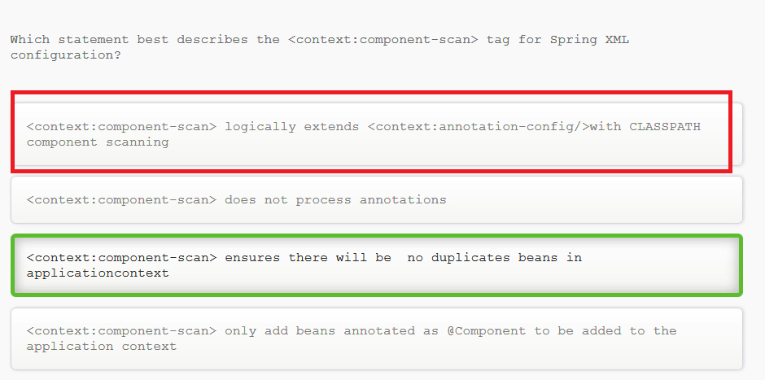

Which statement best describes the <context-component-scan> tag for Spring XML configuration?

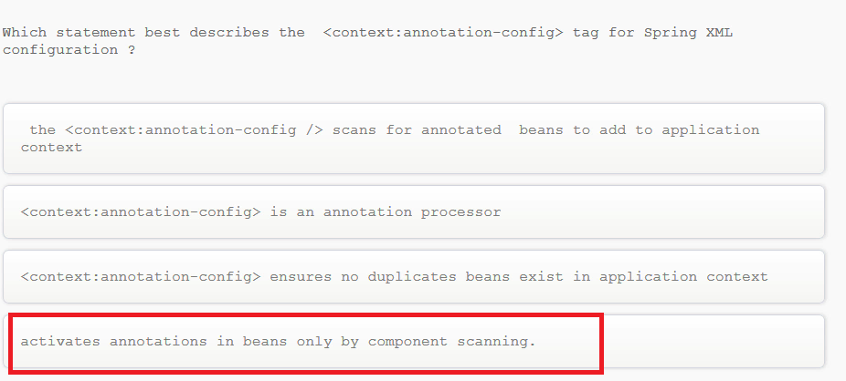

Which statement best describes the <context:annotation-config> tag for Spring XML configuration ?

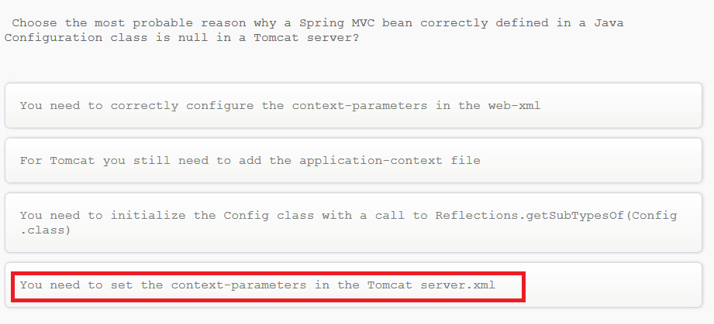

Choose the most probable reason why a Spring MVC bean correctly defined in a Java Configuration class is null in a Tomcat server?

You need to correctly configure the context-parameters in the web-xml

For Tomcat you still need to add the application-context file

You need to initialize the Config class with a call to Reflections.getSubTypesOf(Config.class)

You need to set the context-parameters in the Tomcat server.xml

The difference between server.xml and web.xml

The server.xml file is a server dependent deployment  descriptor which is used to specify server specific configurations . There is only one server.xml for each server instance.   
The web.xml file is used to specify the web application specific configurations.  This is a server independent deployment descriptor and exists one for each web application deployed in the server.   
Thus a server hosting several web applications would have several web.xml files i.e one for each web app but only a single server.xml file.

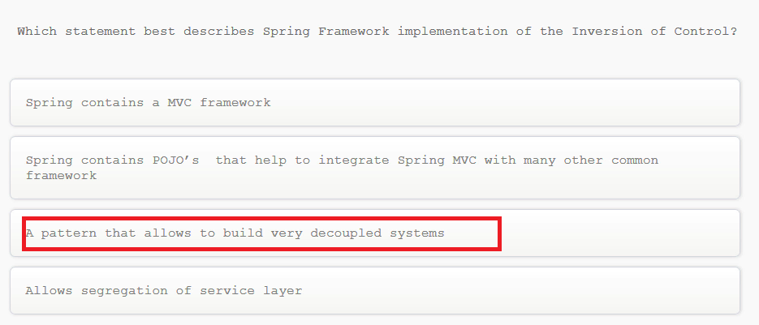

Which statement best describes Spring Framework implementation of the Inversion of Control?



Which statement best describes Spring Framework implementation of the Inversion of Control?

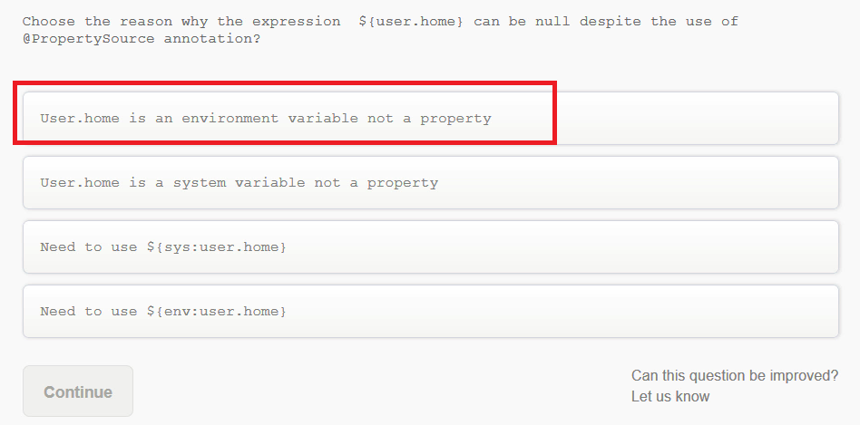

Choose the reason why the expression ${user.home} can be null despite the use of @PropertySource annotation?

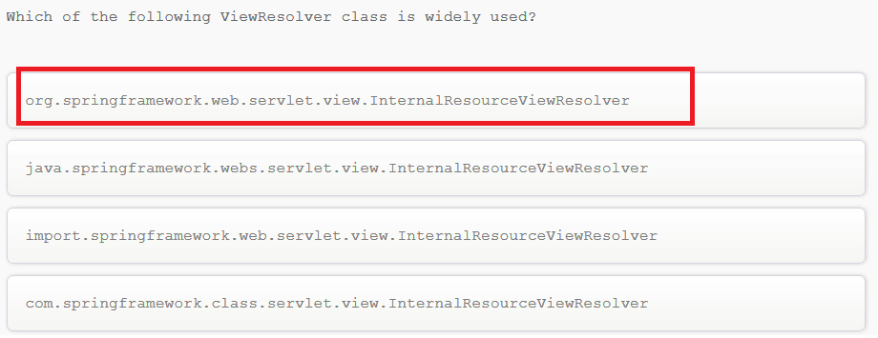

Which of the following ViewResolver class is widely used?

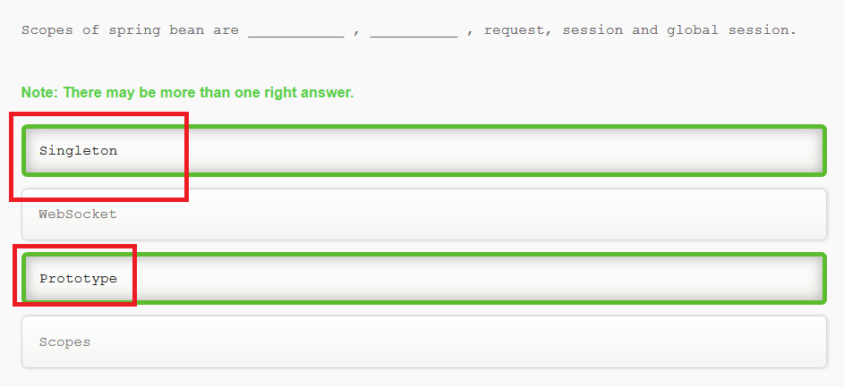

Scopes of spring bean are…

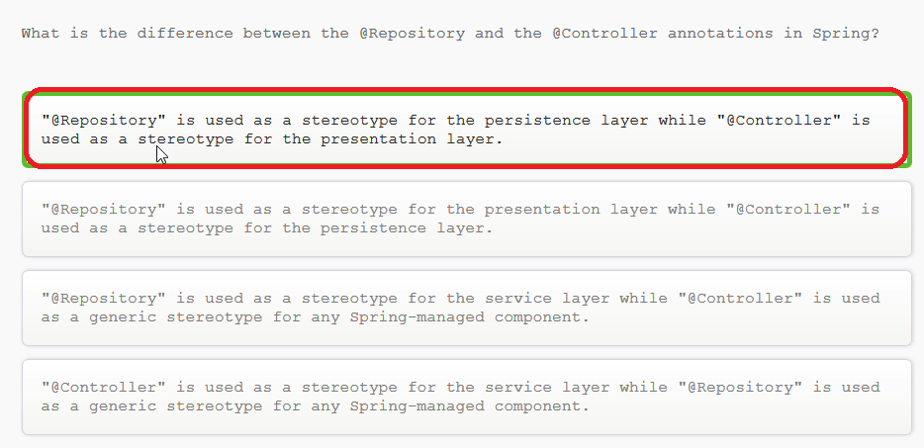

What is the difference between the @Repository and the @Controller annotations in Spring?

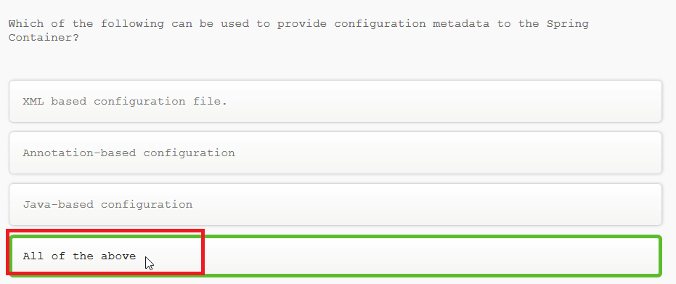

Which of the following can be used to provide configuration metadata to the Spring Container?

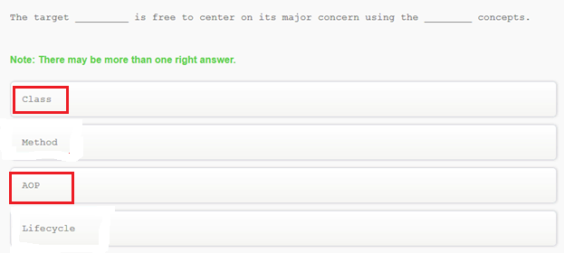

The target ___ is free to center on its major concern using the ____ concepts

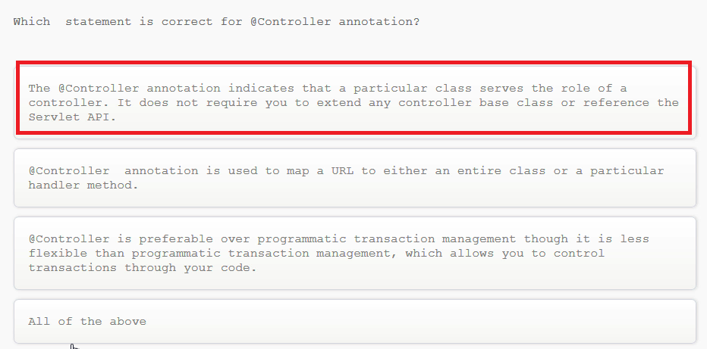

Which statement is correct for @Controller annotation?

<https://docs.spring.io/spring/docs/3.0.0.M3/reference/html/ch16s11.html>

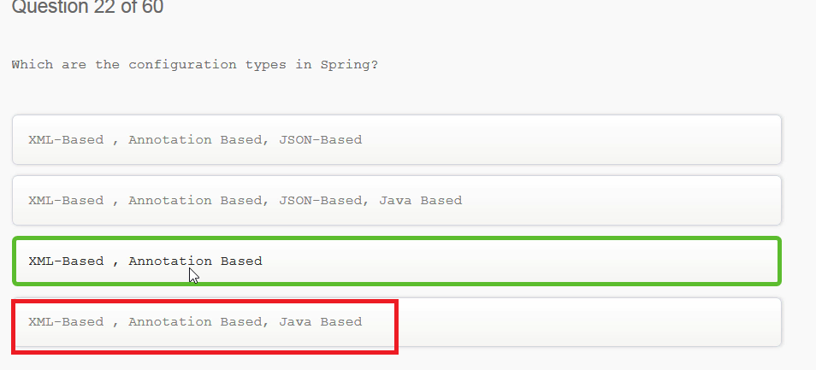

Which are the configuration types in Spring?

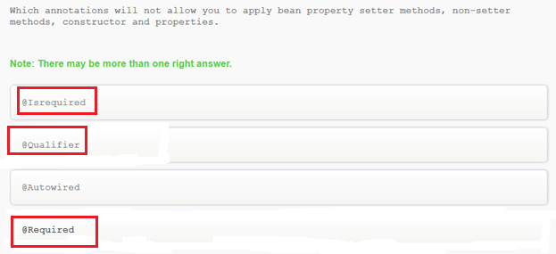

Which annotations will not allow you to apply bean property setter methdos, non-setter methods, constructor and properties.

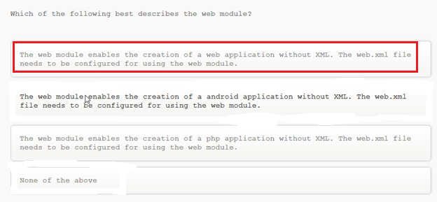

Which of the following best describes the web module?

<https://career.guru99.com/wp-content/uploads/wp-post-to-pdf-enhanced-cache/1/top-50-spring-questions-and-answers.pdf>

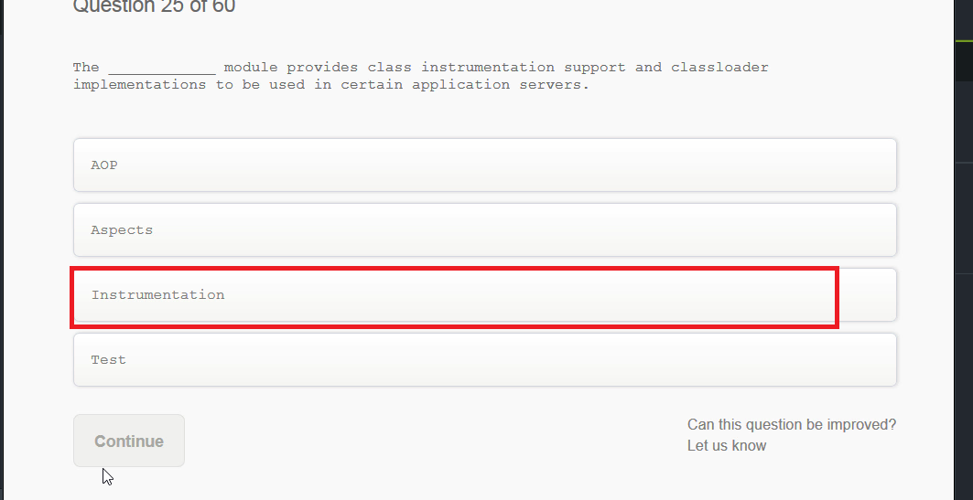

The ___ module provides class instrumentation support and classloader implementatiosn to be used in certain application servers.

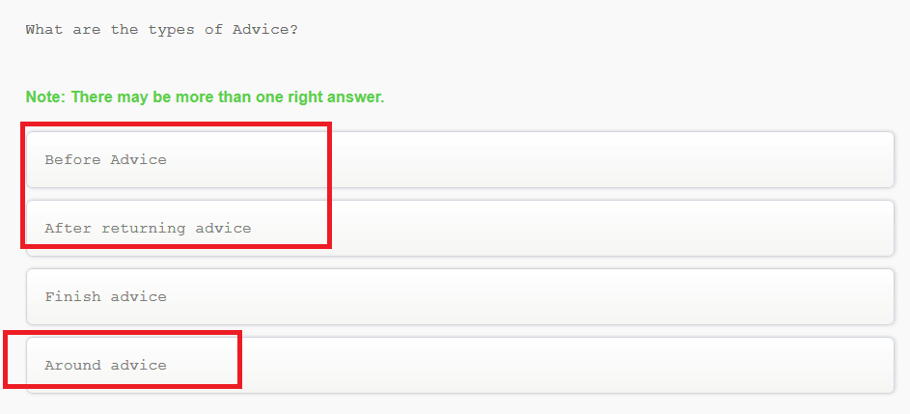

What are the types of Advice?

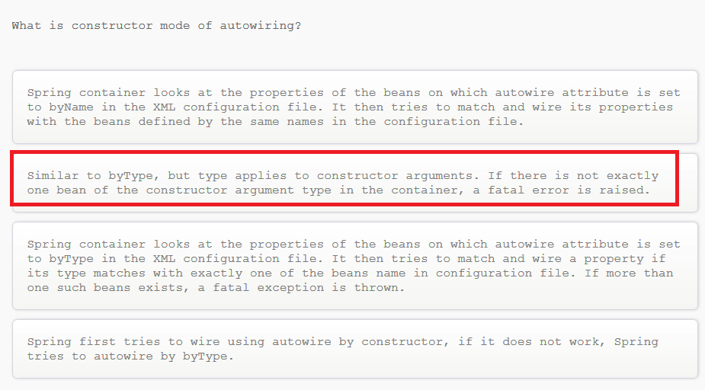

What is constructor mode of autowiring?